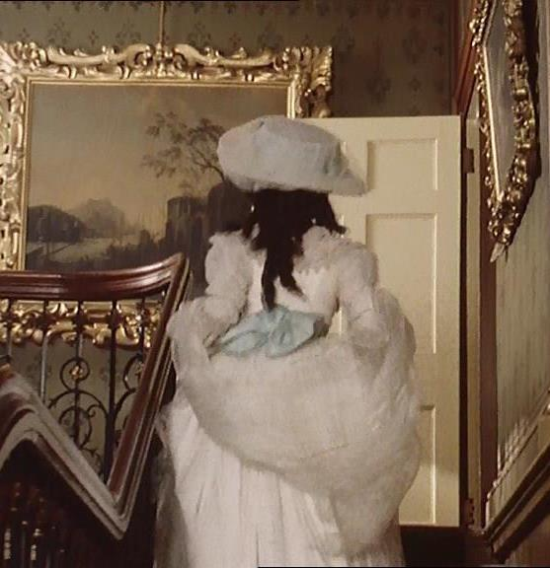

REPLACEMENT

Conference 8-10 Dec 2016

Birkbeck, University of London

Conference at BRAKC: Birkbeck Research in Aesthetics of Kinship and Community

We gratefully acknowledge the support of BRAKC and the Birkbeck Institute for Social Research.

Programme

NB All rooms are in 43 Gordon Square, London WC1H 0PD

THURSDAY 8 DECEMBER

9-10 registration/coffee room GOR B06
10-11 1st parallels
Group 1a Opener room GOR 322
Martina Domines Veliki Haunting children in Wordsworth and De Quincey
Nagihan Halilolu Replacement & genealogy in Jane Eyre & Wide Sargasso Sea

Group 1b Family dramas room GOR 324
Michelle Sherwin The Autobiography of a Haunting: An Analysis of Jamaica Kincaid’s Paradox and the Absence of Replacement
Kelli Weston A mother’s ‘choice’: maternity and death in the shadow of cultural trauma

Group 1c Cinematic dehumanisation room GOR B06
Georgia Panteli Artificial intelligence and synthetic humans: loss and replacement
Sabrina Schneider The Dissolution of the Self and the Dehumanisation of Time in Bolor, by Augusto Abelaira

11-11.15 brief break

11.15-12.15 2nd parallels

Group 2a Holocaust stories room GOR 322
Susanne Baackmann Personal Haunting and Cryptographic Writing in Recent Postmemory Work: Hans-Ulrich Teichel’s Writing of Childhood
Shaul Bar Haim Psychoanalysis and political replacement: A micro-history of a Czech girl in the 1953 coronation events

Group 2b Cultural theory room GOR 324
Catherine Guy-Murrell The Mater dolorosa: a figure of sorrow
Sandra Meiri & Odeya Kohen-Raz
Bodiless-Character-Films, the Replacement of ‘Object a’, and the Dynamic of Desire/Fantasy in Narrative Film

Group 2c Replacement & haunting room GOR B06
Susan Bainbrigge Imagination and palimpsestic play in Agnès Desarthe’s Le remplaçant
Patrizia Grimaldi-Pizzorno Gerty’s hauntology a melodrama of replacement

12-15-1.45 lunch (own arrangements)
and late registrations B06

1.45-2.15 Welcome GOR B04

2.15-4.45 FILM: A Secret (Un Secret, Claude Miller, 2007)
introduced by Naomi Segal room B04

FRIDAY 9 DECEMBER

9-9.30 registration/coffee room GOR B03

9.30-10.30 3rd parallels

Group 3a Political practice room GOR B06
Alexandra Kokoli ‘Dying to live’: Pre-emptive Maternal Mourning in Feminist Anti-Nuclear Art Practices and Visual Cultures
Alison Ribeiro de Menezes From Silhouettes to Ghostly Traces: Replacement and Replication in Lita Stantic’s Un muro de silencio

Group 3b Mother & daughter room GOR G04
Jenny James Lesbian maternity & de-generational desire in Patricia Highsmith’s The Price of Salt
Katrin Wehling-Giorgi ‘I was afraid that my mother had settled in my body’: Haunting Mothers in Goliarda Sapienza’s and Elena Ferrante’s Writings

Group 3c Law & replacement room GOR B04
Sarah Trotter Articulating presence & managing absence: representations of replacement in European human rights law
Sam Ashenden Who is the ‘real’ mother? Replacement, displacement, or multiplication in the contemporary politics of surrogacy

10.30-12 Keynotes: Juliet Mitchell & Naomi Tadmor room GOR B04
Juliet Mitchell Baby no more: the toddler and its replacement sibling
Naomi Tadmor Replacement, early modern kinship, and family life

12-1 lunch (provided) + printmakers: Replacement: Personal hauntings GOR B03

1-2 4th parallels

Group 4a Cinematic self-replacement room GOR B06
James Brown ‘Positively the same dame!’ – replacing oneself in 1940s films
Monika Loewy Embodying her ghost: self-replacement in Petzold’s Phoenix

Group 4b Lost boys room GOR G04
Olivia Noble Gunn Lost Boys in Little Eyolf
Anthony Rudolf ‘Replacement’ or Replacement

Group 4c Musical children room GOR B04
Silke Schauder Van Gogh, Camille Claudel, Michael Jackson: the dead body at work
Bonnie Millar Resonances of Loss and Replacement: Spouses, siblings and children in Sir Orfeo and Amis and Amiloun

2-5 FILM: Rebecca (Alfred Hitchcock, 1940)
introduced by Laura Mulvey GOR cinema

SATURDAY 10 DECEMBER

9.30-11 5th parallels

Group 5a Clinic & culture room GOR B04
Liz Hughes The Replacement Child and Adoptive Experience: Psychoanalytic Perspectives
Agnieszka Piotrowska Replacement in Stories We Tell
Valerie Walkerdine Looking for Laura: Personal haunting and artistic research

Group 5b Spatial replacement room GOR G04
Marija Dalbello The Metaphysics of Replacement in Text-Image Forms
Elizabeth Watkins Cartographies of the Replaced
Deborah Wright Rooms as Replacements for People: The Consulting Room as a Room Object

11-11.30 coffee room GOR B03

11.30-1 Keynotes Jean Owen & Naomi Segal room GOR B04
Jean Owen Replaced mothers, bed tricks and daughters out of place
Naomi Segal An eye for an eye or a mile to a mile: versions of replacement

1-2.30 lunch (own arrangements)

2.30-4 6th parallels

Group 6a Child cases room GOR B04
Christine Anzieu-Premmereur Disorganization and manic defenses in a 7-year old girl after the death of a baby brother and the pathological mourning in the mother
Jennifer Davids ‘I’ll be him for you’
Loreta Gandolfi Truffaut’s opus as a trajectory of (ir-)replaceable children, fathers and mothers

Group 6b Death and catharsis room GOR G04
Michael Amico Why is Antigone’s brother irreplaceable?
Mary Hamer Replacement: moving into danger
Sarra Kassem Death and the transformative effects of mourning in Fatih Akin’s Auf der anderen Seite

4-4.30 tea GOR room B03

4.30-6.30 FILM: 45 Years (Andrew Haigh, 2015)
introduced by Andrew Asibong room GOR B04

6.30-7.30 general discussion & future plans room GOR B04

8 dinner at The Ambassadors hotel, 12 Upper Woburn Place, WC1H 0HX

